TEI480T+How to configurate NAT Entry Setting (Session Limit)
Product line: Router Question category: Function configurations

Q：Why we need to set NAT Entry Settings
A：1) It can prevent some P2P software taking too many sessions which may cause network slowing down or disconnecting from internet, it also can avoid P2P software using too much bandwidth indirectly.
2) It can avoid resource or bandwidth consumption by some attack or virus which will require large sessions.

Step 1: Login to 192.168.0.1, Go to Behavior Management->Bandwidth&NAT Entry Setting
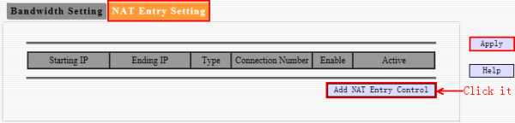

Step2: Take following as example.
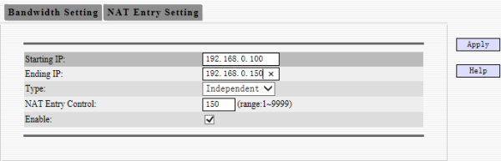
Type: Independent means the each Ip use 150 NAT Entry.
Share means all IP in the IP range share only 150 NAT Entry.

Notice: 150 NAT Entry is a recommand value for each IP. There is no necessary relation between NAT Entry and speed. If there are many NAT entries, that doesn’t mean high network speed. Otherwise, when you have high speed, it also doesn’t mean you have many NAT entries. But it will get high speed if there are many sessions assigned.

